Finite Element Analysis
Purpose
To verify that the LiDAR bracket can support the LiDAR without deformation, three loading conditions were evaluated. First, the bracket was analyzed under the static weight of the LiDAR. Second, it was subjected to a 5 g load to simulate impact forces experienced during a fall. Finally, the bracket was evaluated under centrifugal loading resulting from motor-driven rotation.
Geometry
The geometry used for the finite element analysis was based on the final CAD model of the LiDAR bracket, both the sheet metal spine and aluminum tub. The model includes the mounting holes for the LiDAR, the attachment points to the motor shaft, and the primary load-bearing structure of the bracket. Non-critical features that would not significantly affect the results were simplified to improve meshing quality and reduce simulation time.
Boundary Conditions
The LiDAR bracket was constrained at the screw holes corresponding to its attachment points to the motor shaft to accurately represent boundary conditions. The system was subjected to gravitational loading, with material properties assigned to the LiDAR to reflect its mass and resulting weight. This setup allowed for evaluation of the bracket’s overall deformation to verify that it can adequately support the LiDAR.
Material Properties
Because the LiDAR is composed of multiple materials, a single representative material was selected to approximate its mass based on the datasheet specifications; magnesium alloy was chosen for this purpose as it was closest in mass. The LiDAR bracket was assigned A36 carbon steel, and the cable tub was assigned 6061 aluminum alloy. These materials best reflected the real prototype and thus gave us the most accurate data possible in our simulation.
Mesh Settings
Triangular (CPS3) elements were used for meshing, as this was the available option in SOLIDWORKS. To mitigate the inherent inaccuracies associated with triangular elements. We set the mesh settings to the max that our computers could handle to get the most accurate results.
Output
Below are the screenshots of the FEA analysis work that we did. We tested it under normal and extreme conditions; the most extreme condition was the LiDAR bracket under 5G’s while rotating. With the least being the LiDAR static under normal gravity. Below are all the pictures that we took from our various FEA analysis. As seen by the spectrum on the side, none of the results move a concerning amount as they all move within .003-.02 mm which is negligible since steel moving that distance won’t plastically deform or weaken it.

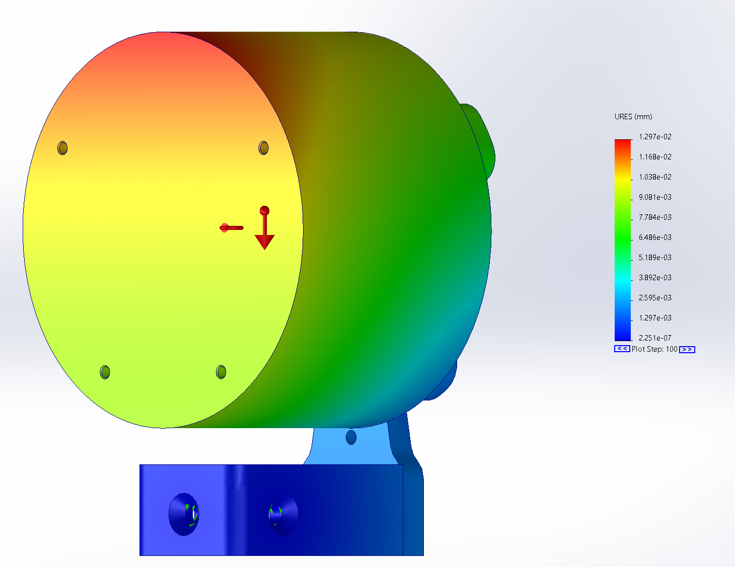
Figure K1. Finite Element Analysis Results for the Front Rotational Loading Case with an Applied +5g Acceleration
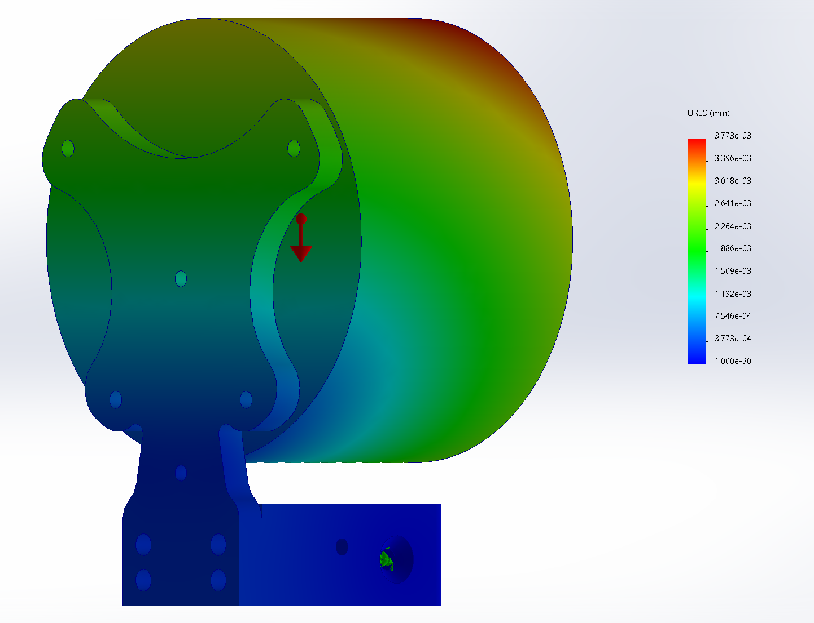
Figure K2. Finite Element Analysis Results for the Back Loading Case Under Normal Gravity
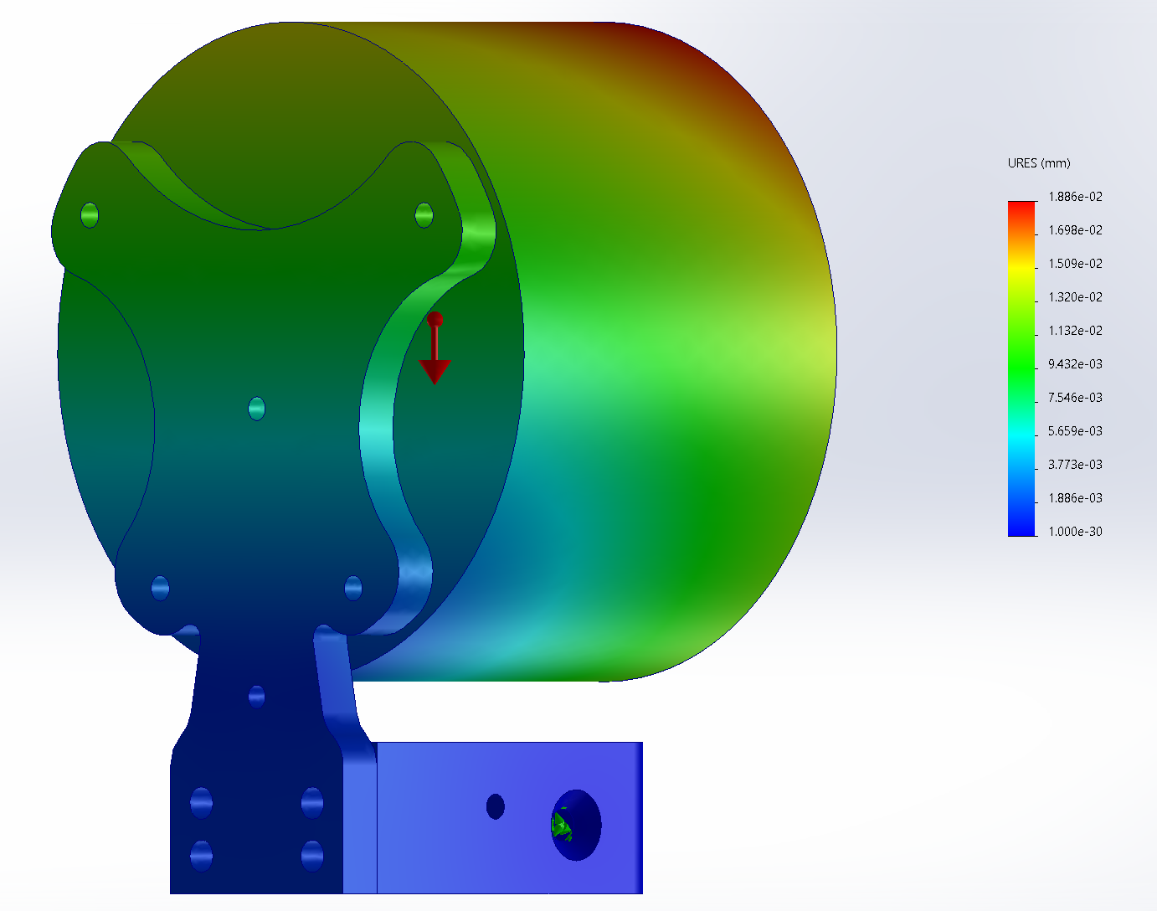
Figure K3. Finite Element Analysis Results for the Back-Loading Case Under 5x Gravity
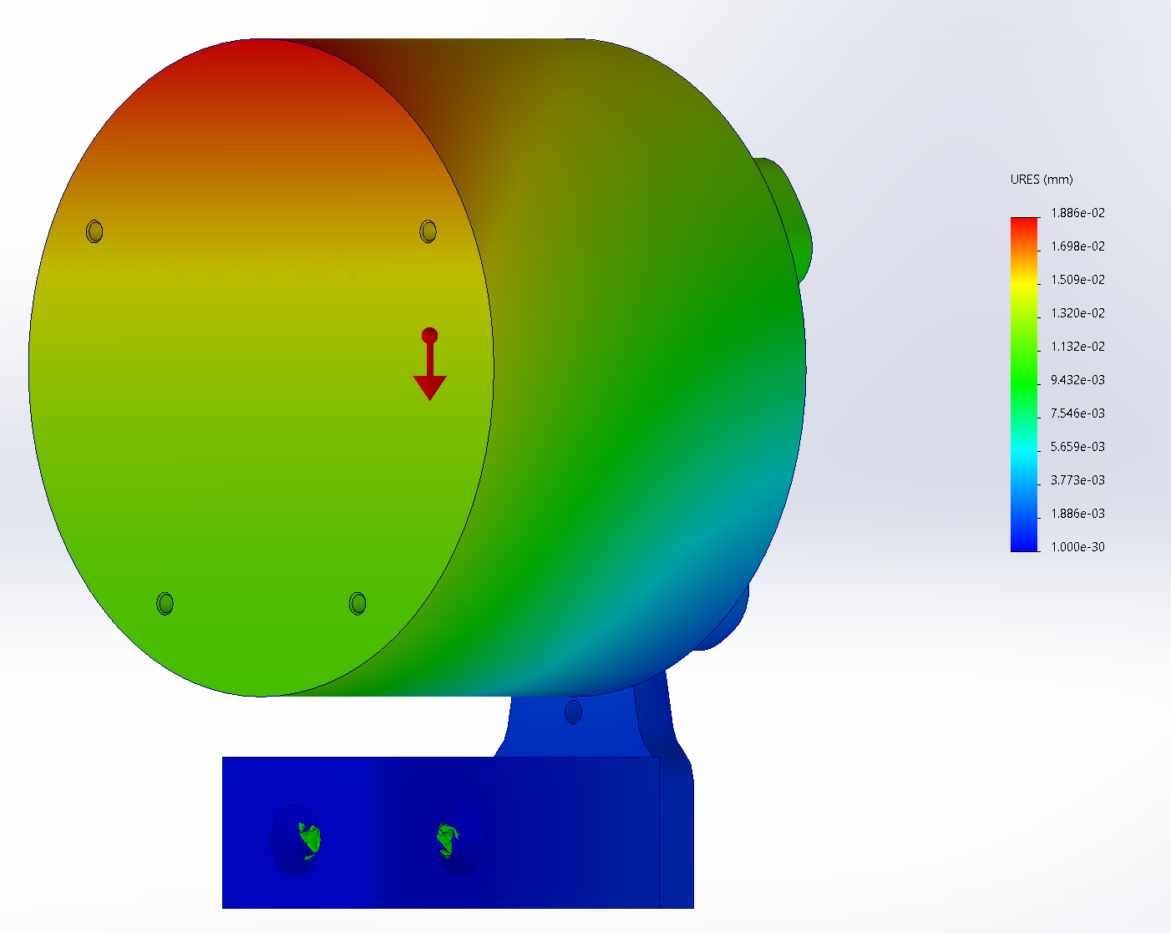
Figure K4. Finite Element Analysis Results for the Front-Loading Case Under 5x Gravity
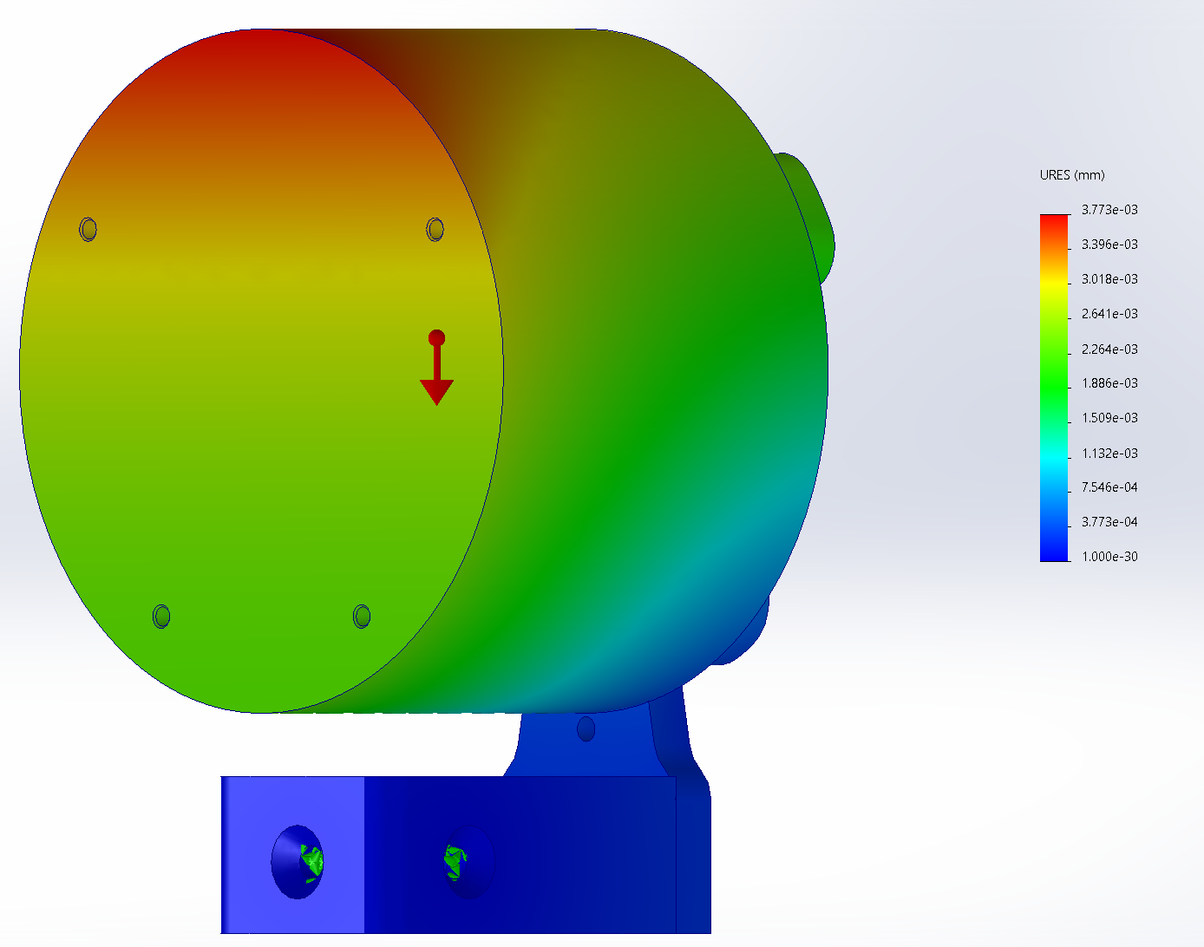
Figure K5. Finite Element Analysis Results for the Front-Loading Case Under Normal Gravity
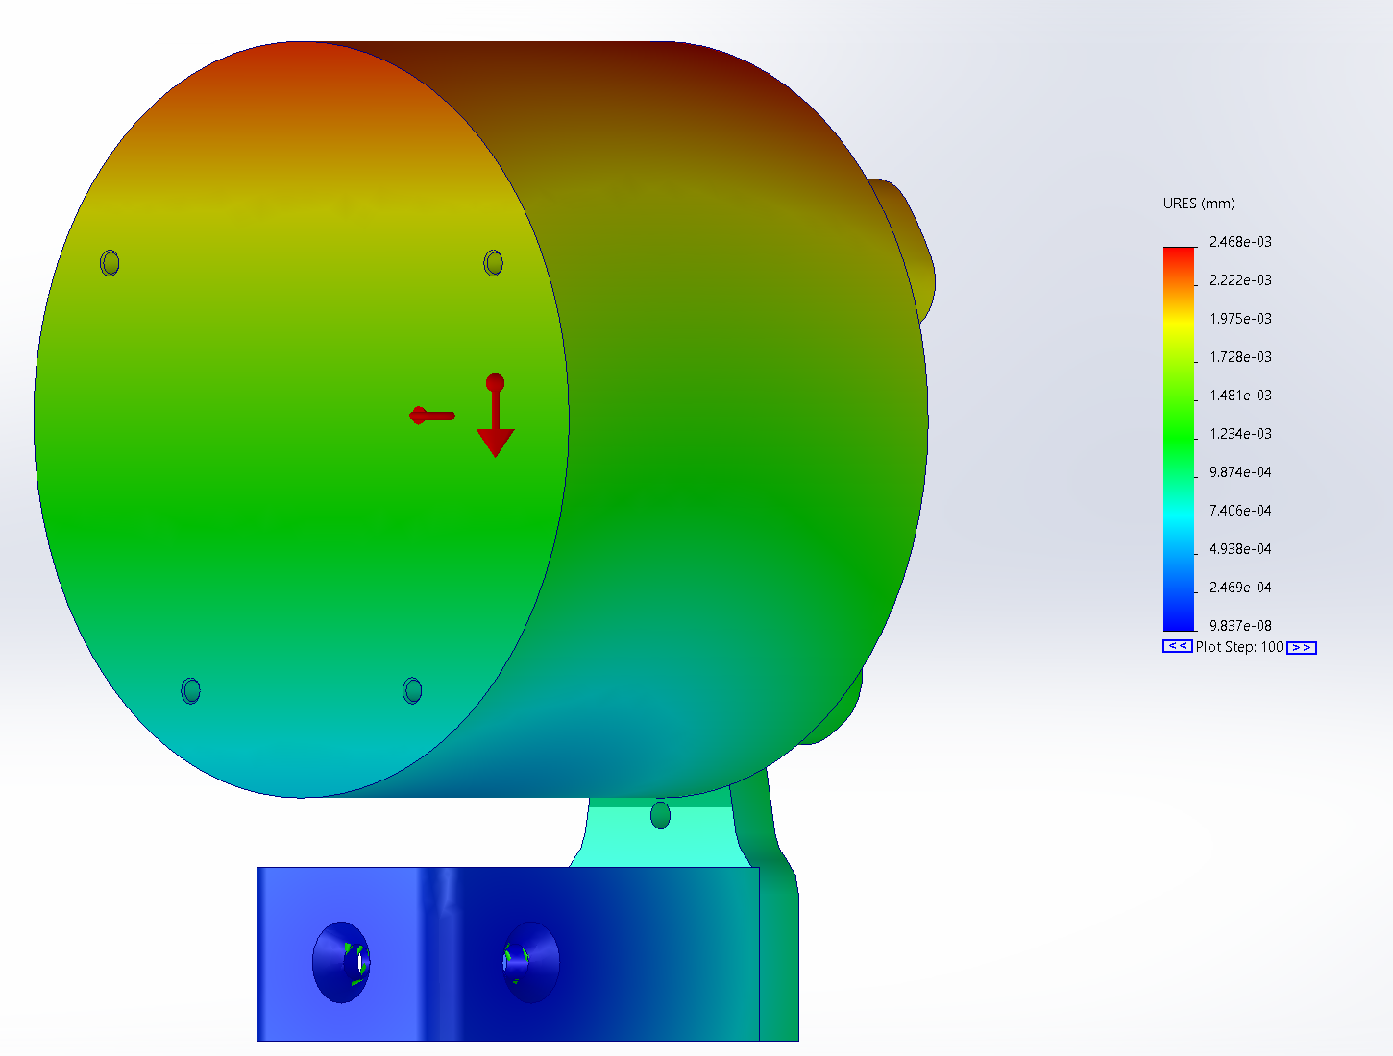
Figure K6. Finite Element Analysis Result for the Front Rotational Loading Case
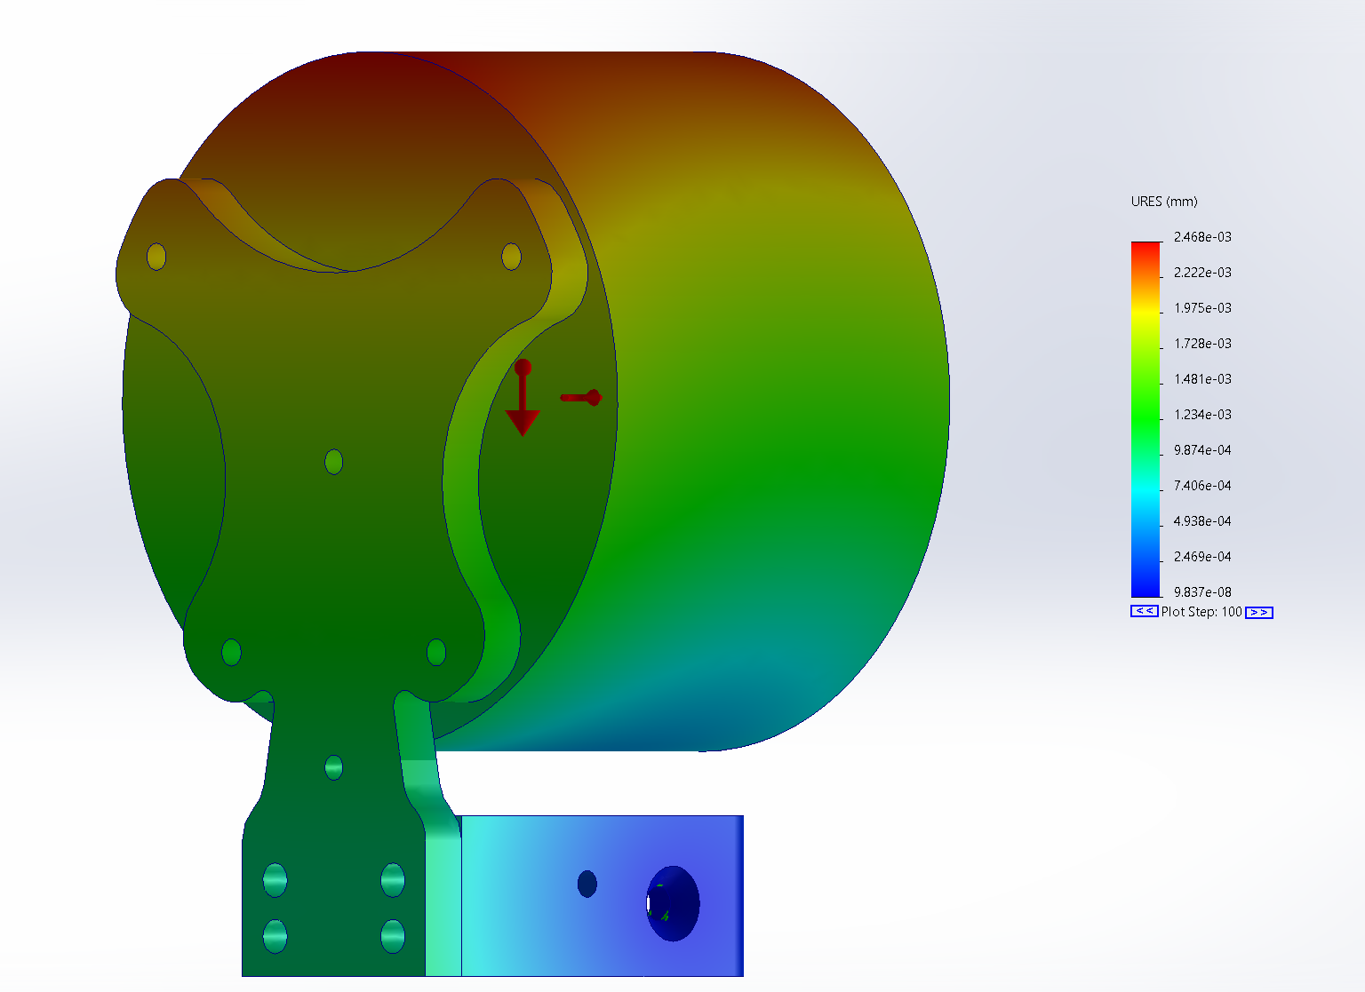
Figure K7. Finite Element Analysis Results for the Back Rotational Loading Case
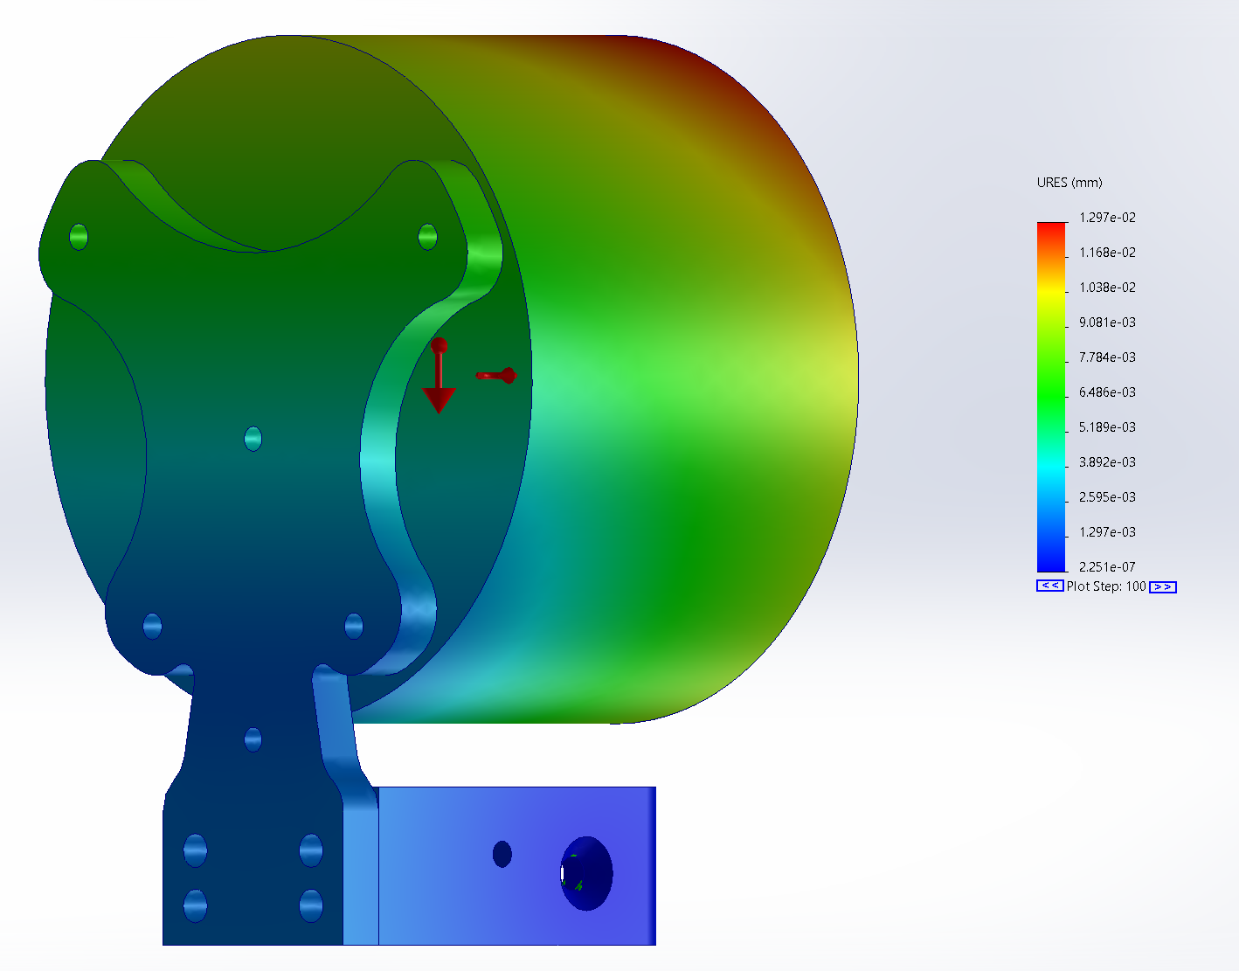
Figure K8. Finite Element Analysis Results for the Back Rotational Loading Case with an Applied +5g Acceleration

